Student Performance Prediction System

Project Id: AIML-5

Name: Anushka Diwaker (Team Leader)
Class Roll Number: 32
University Roll Number : 2028654
Section and Group: G, G1

Name : Jayna Kothari
Class Roll Number: 10
University Roll Number: 2028438
Section and Group: G, G1

TABLE OF CONTENTS
- Problem Description 3
  - Dataset Description 3
  - Flow diagram 4
- Modules for Project Implementation…………………..…………………………5
  - Modules Used 5
  - Platform Used 6
- Machine Learning model/ Searching Technique used 7
- Evaluation metrics used 8
- Results and Visualizations 9
- Conclusion and Future Scope 11
- References 12

- Problem Description
Design and develop an end-to-end machine learning system to predict user movie preferences based on Netflix user rating history. The project should involve selecting a suitable dataset containing user IDs, movie IDs, ratings, and timestamps. Preprocessing should include handling missing values, cleaning duplicate records, normalization of rating values, and transformation of categorical attributes (user/movie IDs encoding). Relevant features such as user viewing behavior, movie popularity, genre, and historical rating patterns should be identified using feature selection techniques. The system should include model training using Logistic Regression, KNN, and SVM classifiers to classify user preference categories (such as Like/Dislike or High Rating/Low Rating). The models should be evaluated using classification performance metrics including accuracy, precision, recall, F1-score, confusion matrix, and ROC curve. The project should demonstrate a complete ML pipeline from raw rating dataset to evaluated predictive models. Expected Output: 1 : High Rating / Recommended 0 : Low Rating / Not Recommended

  - Dataset Description

The dataset used in this project contains movie-related information along with user interaction features. Each record represents a movie with attributes such as userId, genres, original_language, budget, revenue, runtime, popularity, vote_average, vote_count, and release_date.

During preprocessing, the dataset was cleaned by removing duplicates, handling missing values, and converting data types. The release_date was transformed into release_year for simplicity.

A target variable label was created from vote_average:
- 1 → High Rating / Recommended
- 0 → Low Rating / Not Recommended
This converts the problem into a binary classification task for predicting user movie preferences.

1.2 Flow Diagram

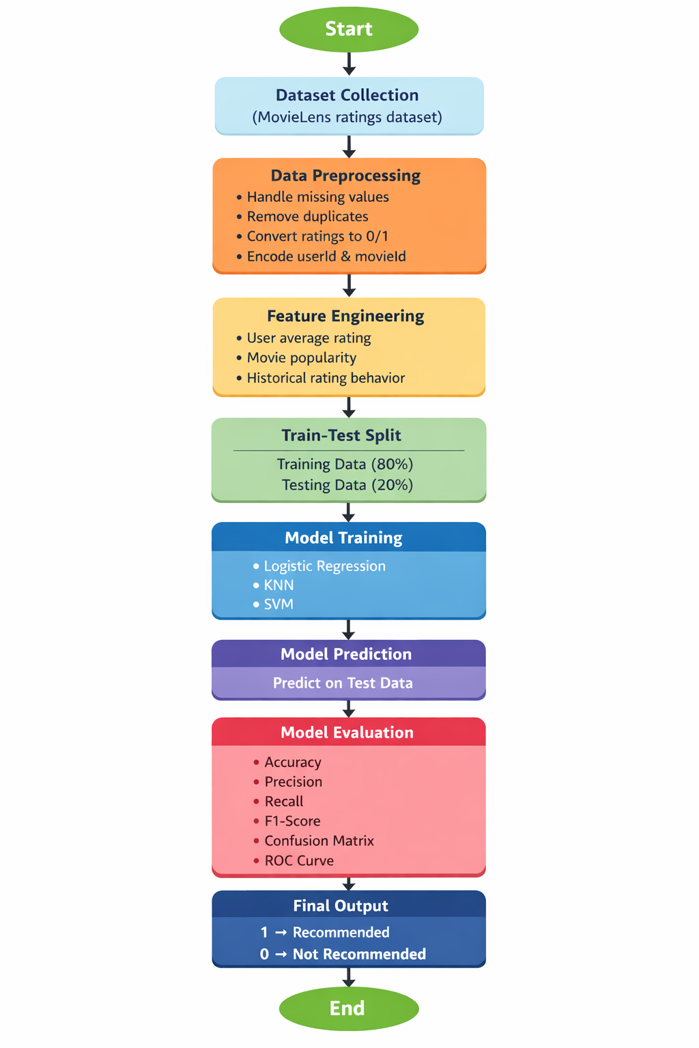
Fig.1 flow diagram.

Modules for Project Implementation

2.1 Modules Used(mention all the inbuilt/ custom modules used and the purpose)

The following inbuilt and external Python modules are used in the project for data processing, model building, and visualization:

- Pandas
Pandas is used for data manipulation and analysis.

Functions used:

- pd.read_csv() – to load dataset from CSV file
- df.drop() – to remove unnecessary columns
- df.drop_duplicates() – to remove duplicate records
- df.fillna() – to handle missing values
- df.replace() – to replace null-like values
- df.to_csv() – to save processed dataset
- df.corr() – to compute correlation matrix
- pd.get_dummies() – to convert categorical data into numerical form

- Numpy
NumPy is used for numerical computations and handling arrays.
Functions used:
• np.array() – To create arrays
• np.mean() – To calculate mean values
• np.std() – To calculate standard deviation

- Matplotlib
Matplotlib is used for data visualization.
Functions used:
- plt.figure() – to create a figure
- plt.plot() – to plot graphs
- plt.xlabel(), plt.ylabel() – to label axes
- plt.title() – to add title
- plt.show() – to display plots
- Seaborn
Seaborn is used for advanced and attractive statistical visualizations.

Functions used:

• sns.heatmap() – To display correlation heatmap
• sns.countplot() – To show frequency distribution

- Scikit-learn (sklearn)

Seaborn is used for advanced data visualization .

Functions used:

a) Model Selection
- train_test_split() – to split data into training and testing sets

b) Preprocessing
- StandardScaler() – to normalize feature values
- LabelEncoder() – to convert categorical labels into numeric form

c) Models
- LogisticRegression() – for binary classification
- KNeighborsClassifier() – for KNN classification
- SVC() – for Support Vector Machine classification

d) Evaluation Metrics
- accuracy_score() – to measure model accuracy
- precision_score() – to measure precision
- recall_score() – to measure recall
- f1_score() – to measure F1-score
- confusion_matrix() – to evaluate prediction results
- classification_report() – to generate detailed performance report
- roc_curve() – to plot ROC curve
- auc() – to calculate area under ROC curve

2. Platform Used

The following platforms are used for the development and implementation of the project:

• Visual Studio Code:
For code writing, testing, and debugging. It provides useful extensions and debugging tools that enhance development efficiency.

• Jupyter Notebook:
For interactive coding and step-by-step execution of the machine learning pipeline. It allows easy visualization of outputs such as graphs and tables, making analysis and debugging simpler.

• Python:
Programming language used for implementing the entire machine learning pipeline due to its simplicity and rich library support.

- Machine Learning Model/ Searching Technique Used(Describe each ML model/ searching technique used)

In this project, three machine learning models and one parameter tuning technique were used to predict user movie preferences.

1. Logistic Regression
Logistic Regression is a supervised learning algorithm used for binary classification. It predicts the probability that a given input belongs to a particular class using a sigmoid function. In this project, it is used to classify movies as High Rating (1) or Low Rating (0).

2. K-Nearest Neighbors (KNN)
KNN is a distance-based classification algorithm that classifies a data point based on the majority class of its nearest neighbors. It does not make assumptions about data distribution and works well for pattern-based classification.

3. Support Vector Machine (SVM)
SVM is a supervised learning algorithm that finds the optimal hyperplane to separate data points of different classes. It is effective in high-dimensional spaces and provides good classification performance.

4. Searching Technique: Elbow Method (for KNN)
The elbow method was used to determine the optimal value of K in the KNN algorithm. It involves plotting the error rate against different values of K and selecting the value where the error is minimized.

4. Evaluation metrics used (Describe each evaluation metric used along with formulae)

The performance of models is evaluated using the following metrics:

  - Accuracy
Measures overall correctness of the model.
Formula:
Accuracy = (TP + TN) / (TP + TN + FP + FN)

  - Precision
Measures how many predicted positives are actually correct.
Precision = TP / (TP + FP)

  - Recall (Sensitivity)
Measures how many actual positives are correctly identified.
Recall = TP / (TP + FN)

  - F1 Score
Harmonic mean of precision and recall.
F1 Score = 2 × (Precision × Recall) / (Precision + Recall)

  - Confusion Matrix
A table used to evaluate classification performance showing TP, TN, FP, FN.

5. Results and Visualizations

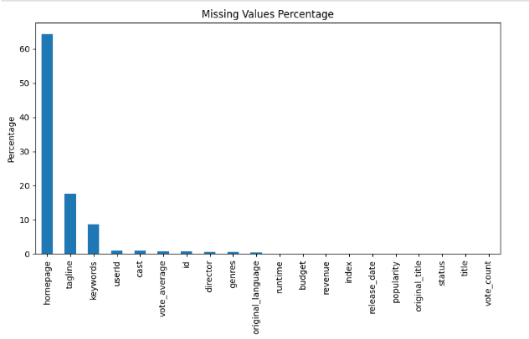
Fig.2

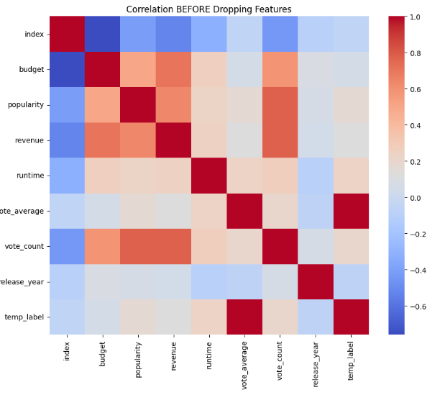
Fig.3

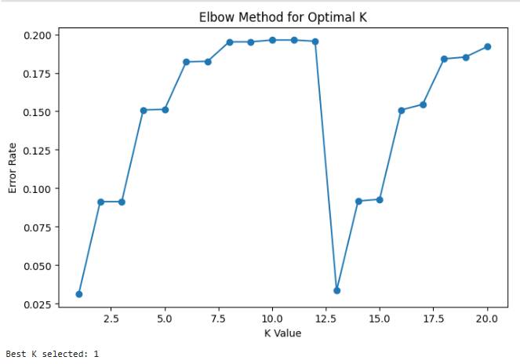
Fig.4

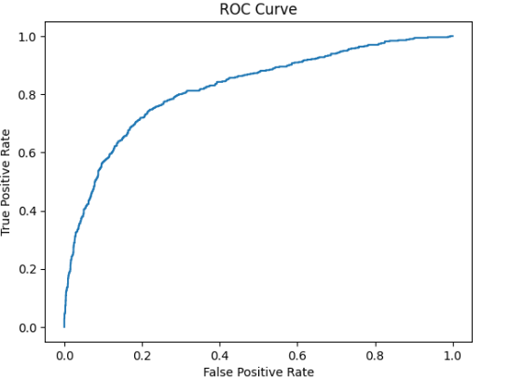
Fig5

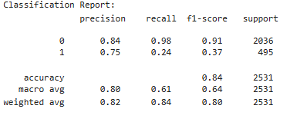

  - Conclusion and Future Scope:

Conclusion

In this project, an end-to-end machine learning pipeline was developed to predict user movie preferences based on movie features and rating data. The dataset was preprocessed by handling missing values, removing duplicates, and transforming categorical features into numerical form. A target variable was created to classify movies as High Rating (Recommended) or Low Rating (Not Recommended).
Three classification models—Logistic Regression, KNN, and SVM—were implemented and evaluated using metrics such as accuracy, precision, recall, F1-score, confusion matrix, and ROC curve. The results demonstrate that machine learning techniques can effectively predict user preferences and assist in recommendation systems.

Future Scope

- Incorporate actual user rating history with timestamps to better model user behavior
- Apply advanced recommendation techniques such as collaborative filtering and hybrid models
- Use deep learning models for improved prediction accuracy
- Perform hyperparameter tuning to further optimize model performance
- Deploy the model as a web-based recommendation system for real-time usage

7. References:
Books:
- Let Us Python – Yashavant Kanetkar

Machine Learning tutorials and examples from:
  - GeeksforGeeks (https://www.geeksforgeeks.org/)
  - Towards Data Science articles
  - Kaggle notebooks and datasets

Online Resources:
  - TutorialsPoint – https://www.tutorialspoint.com/cprogramming/index.htm
  - Stack Overflow – https://stackoverflow.com

